**Coffee Beans Application**

**Tools and Technologies:**

Laravel Framework, PHP, Blade template, CSS, Bootstrap, HTML, Sqlite, AWS

**Functionality**

Base functionality:

* All CRUD operations working.

Additional functionality

* Field validation warning for empty fields.
* Add/Update/Delete success messages.
* Confirmation message for delete entry.
* CSS
* Easy navigation/pagination
* AWS hosting <http://laravelapplication-env.eba-7pmeevmh.us-east-2.elasticbeanstalk.com/coffeeBeanTable>
* Requirement document
* Functional/Integration Tests document

Future Functionality

* Unit testing (Future)
* UI Enhancements (Future)

**Snapshots:**

* Home Page:

* Pagination

* Create entry page

* Create entry page field validation

* Create entry page combo box menu

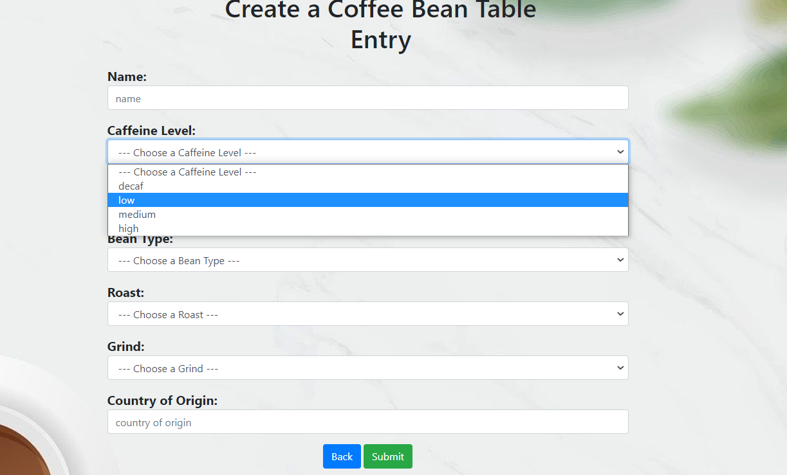

* Filling fields on Create entry page

* Showing add entry successful message

* Edit Coffee Bean Table Entry page

* Edit Coffee Bean Table Entry page validation

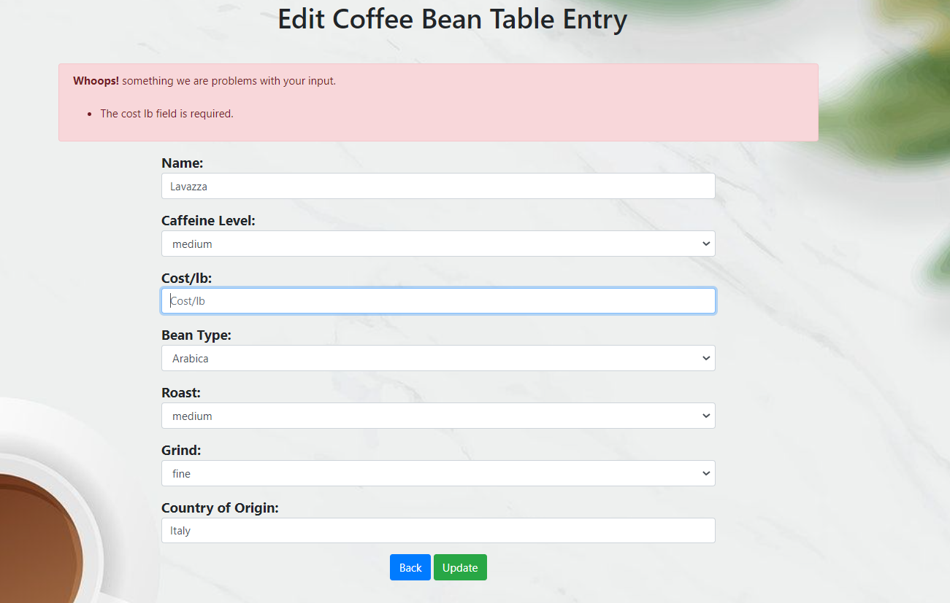

* Editing Coffee Bean Table Entry

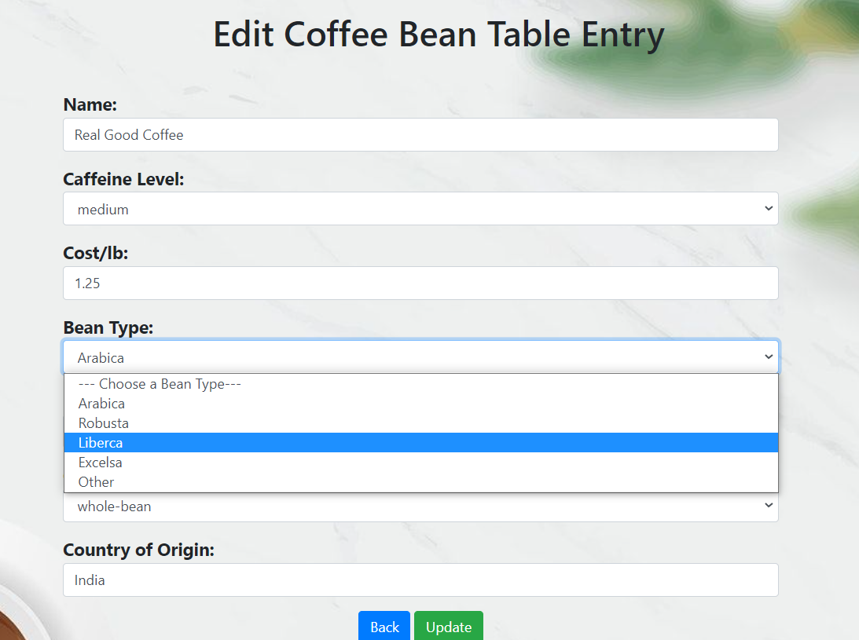

* Showing edit entry successful message

* Showing delete entry confirmation message

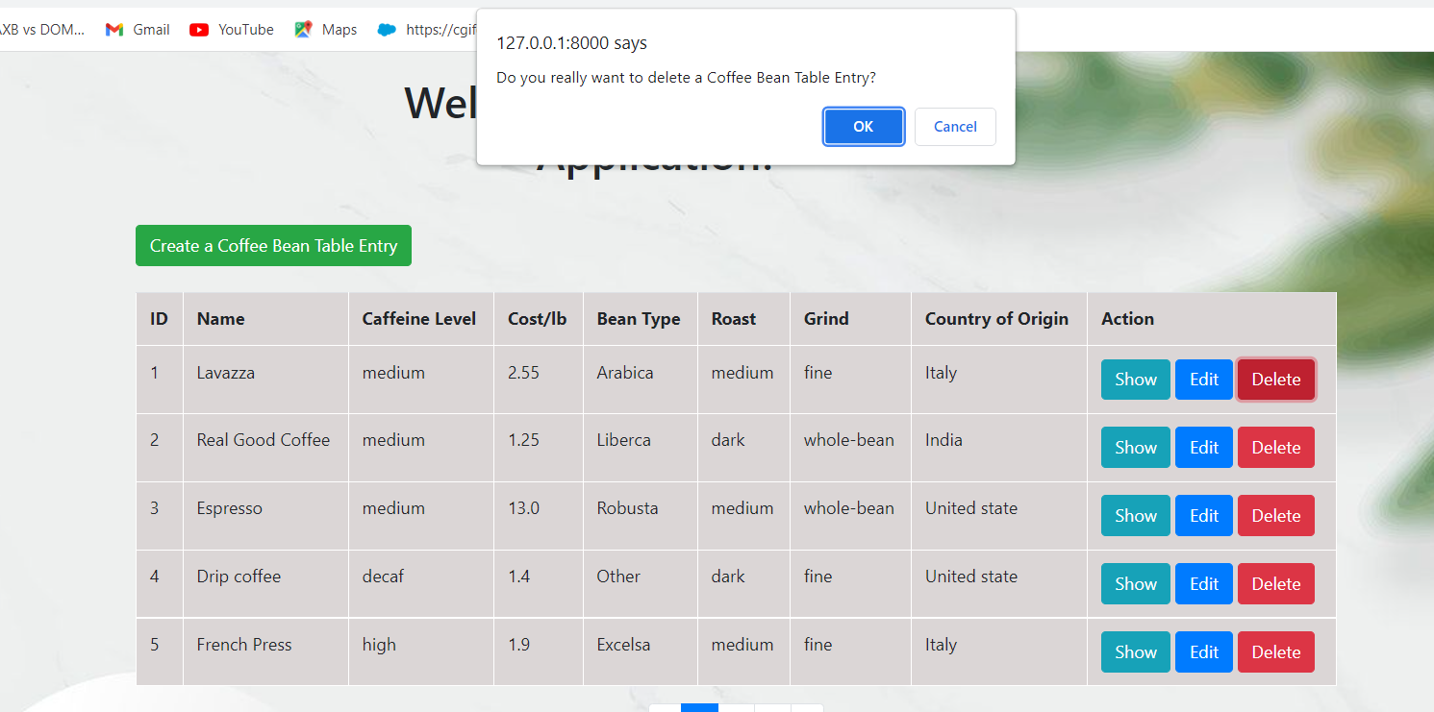

* Showing delete entry successful message

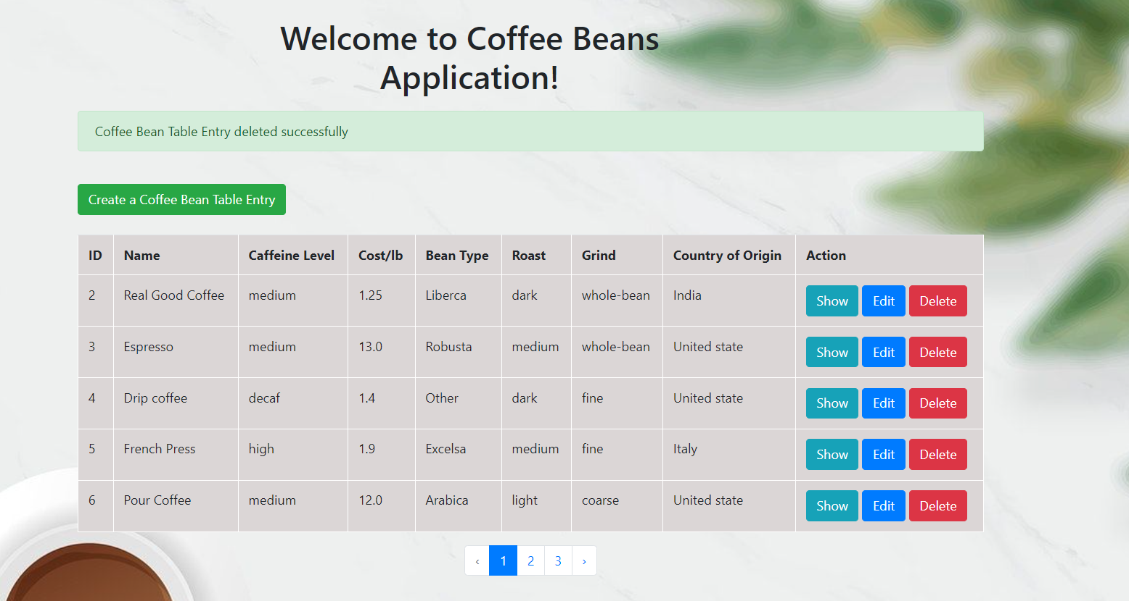

* Showing Coffee Bean Table Detail page

